Managerial Decision for firms with Market Power
Name of Author:
Institution:
Date:

Research Topic: The Analysis of Managerial Decision for firms with Market Power- Case of Tesla in the Electric Car Industry

Executive Summary
Monopolistic markets are those in which firms have market power but not as totally as monopolies. In these markets, the products of every firm are highly differentiated making them price takers as opposed to being price receivers. Tesla is an example of a monopolistic firm which makes zero-emission cars, which are differentiated from conventional cars that run on fossil fuel. As guided by the theory of monopolistic competition developed by Economist Edward Chamberlin in the early twentieth century, the profit-maximizing output levels are where the marginal costs equal to the marginal revenue. Using the example of Tesla, it is evident that managers need to be conscious of the total cost and total revenue data, so as to map the marginal costs and revenues. A prudent decision in favor of more output quantities occurs when marginal revenues exceed marginal costs while the opposite means the firm incurs losses. Since the firms’ demand curve slopes downwards, they usually operate excess capacity. Decision making in favor of less production inefficiency would involve finding innovative ways to keep production costs as low as possible. Bottom-line, managerial decision-making calls for thorough and accurate analysis of firm performance and market conditions to ensure stability in the long run.

Table of Contents

1. Introduction 4
2. Literature Review 5
2.1 Defining Market Power 5
2.2 Decision Making in Monopolistic Markets 6
2.2.1 Demand Elasticity 6
2.2.2 Case of Tesla & Barriers to Entry 7
3. Theoretical Framework 13
4. Empirical Framework Model for Tesla 16
5. The Analysis of the Equilibrium Empirical Model 17
5.1 Decisions to Quantity and Pricing 17
5.2 Decisions to Variety 18
5.3 Decisions to Efficiency 20
6. Conclusion 21
7. References 23

Introduction
It is usually every management’s aspiration that their company acquires significant market power to drive up its profitability. However, acquiring market power is quite elusive and often available to firms which operate within industries with notably strong barrier to entry by other players. Many times, pioneer firms with specialized technologies, exclusive copyrights/patents and having large economies of scale enjoy trading in markets with enormous market power (Lábaj, et al., 2018). Ideally, in the long run, firms with dominant market power generate above average economic profits due to demand inelasticity (Nowlan, 2018). From economic point of view, the decision making in such monopolistic but competitive markets takes a unique approach. This research paper deeply explores how management decisions are made within firms with market power, within the scope of profit maximization and reduction of the costs. This paper takes the form of a systematic lit review involving an in-depth review of literature as well as theoretical frameworks within this area of study. Finally, an empirical framework modeling will be undertaken followed by an in-depth data analysis to make sense out of the data. Adequate graphic details will be given and thoroughly explained to support key arguments.

Literature Review

Defining Market Power
Firstly, market power is often associated by the fraction of the share of the market that a firm serves within a definite period of time. In putting it differently, market power refers to the ability of a firm to increase the prices of its goods and/or services without suffering loss of its sales (Thomas, and Maurice, 2016). Having market power allows a firm to raise its prices to a level above the average costs and accrue economic profit, when the cost and demand conditions allow it. From an economic perspective, any firm that experiences a downward sloping demand curve implies that the firm has market power. Worth noting, having market power does not always mean that the firm has endless possibilities to output on the market. For instance, in a qualitative survey of a history of market power in the US, Loecker & Eeckhout (2017) found that availability of market power has impacts on allocation.
Ideally, firms with market power, whose prices are above marginal cost produce less in outputs compared to those outside monopolistic markets. Also important to outline, having market power can in itself be a deterrent to better growth and adaptability. Nowlan’s (2018) assessment of the failures in monopoles found that failure to accurately read market trends was a key reason to business failure since most firms get comfortable in conditions that they operate within and fail to be adaptable. There is a need to grow, reinvent and adapt to take opportunities in the market. In a typical example, IBM had greater focus on developing mainframe computers that it failed to venture in personal computers. Even when it eventually did, it used ideas from other firms. It general reluctance to venture into PCs contributed to getting stuck in mainframe computers which became obsolete as other market players went into the more prosperous PC industry (Nowlan, 2018).
  - Decision Making in Monopolistic Markets
    - Demand Elasticity
Before exploring how managerial decisions are made in companies with market power, it is essential to understand how demand play out. Usually in monopolistic markets, the measure of market power rests in the elasticity of demand. Ideally in competitive markets, there is perfect levels of demand elasticity. It means that when demand is more elastic, there is greater percentage decrease in the sales which a company records as the prices increase. In monopolistic markets, the demand elasticity is lower, meaning that there is smaller decrease in sales as prices rise (Cowan, 2018). As an economic standpoint, the extent to which a company amasses market power is inversely proportional to the elasticity of demand. Since such firms with more market power experiences less elasticity of demand, they have more freedom to alter their prices without adverse effects on their sales revenues. This is also informed by lower numbers or complete absence of close subtitles that the consumers can rely on as alternatives (Thomas, and Maurice, 2016). Also, essential to note while the Lerner index (P-MC/P) is zero in perfect competition, the index rises in the monopolistic market due to greater market power (Thomas, and Maurice, 2016). As it in the case of Tesla, the unavailability of similar companies who have commercialized the production and sale of electric cars gives Tesla more market power. If it were to adjust the price of say, its Model X car by 5 percent, the availability of subtitles results in lesser variations to the company’s sales revenues, all other factors held constant.
Lerner Index= (P-MC)/P
Where, P is the price and MC, the Marginal Cost

    - Case of Tesla & Barriers to Entry
For this analysis, Tesla is an example of a firm that enjoys immense market power within the auto making industry. It is a Silicon Valley start-up enterprise that has pioneered the making of zero-emission automobiles (Stringham et al., 2015). Tesla has been for more than two decades ventured in the development of electric cars while other automakers still design diesel engine cars (Debord, 2020). Within the spirit of going green and developing ecofriendly cars, Tesla is a true market leader and pioneer in the field. Its status, relative to other car makers, can be described as a mini-monopoly still its differentiated products ultimately compete with other products from other companies such as Toyota, BMW, Land rover and Tata among many others. Recvlohe’s (2019) assessment of Telsa was that it neither produces fancy cars for wealthy consumers nor offers any unique experience as compared to other automobile products. It is pioneer firm that sought to develop cars that run fully on electricity which makes it a first in this field. It therefore positions itself as an aggressively innovative firm which embeds high technology capabilities to ensure their cars run on electricity as opposed to the diesel engines. In essence, Tesla sells almost every car that it produces on the market which implies operation on a monopolistic market (Thomas, and Maine, 2019: Debord, 2020). The following illustration shows the timeline of Tesla and some of the car models it has developed over time.
Figure 1: Telsa Timeline- (Up to 2017)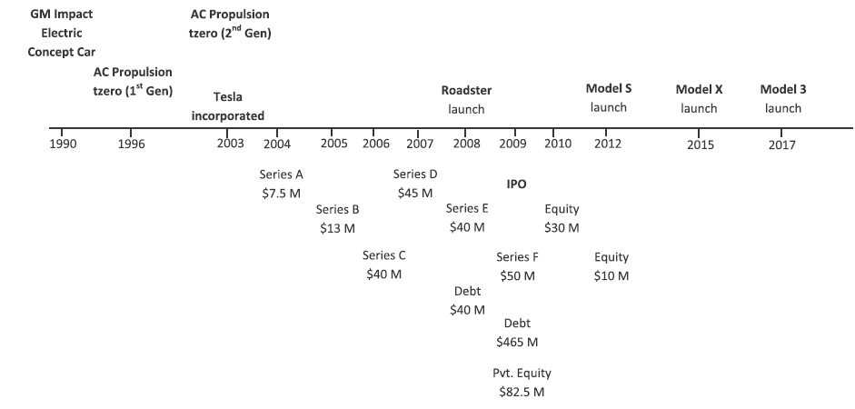
Source: Thomas, and Maine, (2019, p. 657)

One of the distinctive features of low elastic markets are the high numbers of barriers to entry (Rosado-Cubero, 2015). These are financial, operational or other types of difficulties that it are unfavorable to new entrants to operate in the market. For the case of electric vehicles (EV), a pioneer company like tesla operates on a new norm as opposed to conventional operations for other carmakers. While it arguable that other firms are on the verge of making a move on Tesla-like products, the monopoly of knowledge and patents makes the field less receptive to the new entrants. Tesla, in its innovative capabilities have set up unique technologies that support the making of electric cars. Stringham et al.’s (2015) assessment of the barriers to the electric automobile industry noted high set-up and operational costs, enormous economies of scale, and network effects of service lead and distribution. Tesla has made bold steps include taking over a 5.5 Million square feet GM garage at Freemont, California to be its high-technology production plant. The company has invested largely in unique technologies and patented them, including high level expertise and special infrastructure to support the making of the electric vehicles (Stringham et al., 2015). The company has also sought strategic partners such as the Lotus Elise licensed technology to deliver special equipment and technology. These and other features make Tesla as software firm as much as a hardware entity and at one time its owner Elon Musk remarked that a Telsa automobile is “a very sophisticated computer on wheels” (Stringham et al., 2015, p. 94). Therefore the uniqueness of the company to pioneer the production of EVs makes it hard to imitate and it currently enjoys a micro-monopoly in this sector.
    - Profit Maximization Decision
For a firm with market power, the market demand curve is equivalent to the firm’s demand curve. The profit maximization decisions for such a firm is attaining a production quantity where the Marginal revenue (MR) is equal to the marginal cost (MC) in the long run. In this scenario, the cost of producing one extra product should be equal to the revenue that will be earned on the product. As already identified above, a firm operating in a monopolistic market perceives demand to shift in favor of the price. Unlike in a perfect competition, as shown in the illustration below, the demand curve for a firm with market power slants downwards.

Figure 2: Demand Curve; Perfect Competition vs. Monopolistic market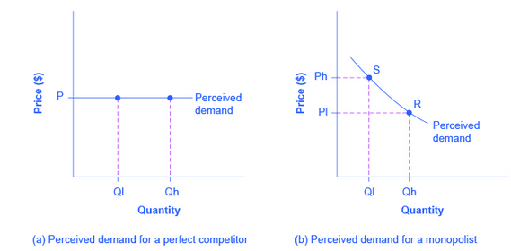
Source: OpenStax, (2016); https://opentextbc.ca/principlesofeconomics2eopenstax/chapter/how-a-profit-maximizing-monopoly-chooses-output-and-price/
The demand curve of a monopolistic firm (which is similar to the market demand curve) implies that should it choose higher amounts of output (Qh), it charges a relatively low price (P1). On the other hand, if it desires low output levels (Q1), it charges a relatively higher price (Ph) (OpenStax, 2016). Therefore, managerial decision lies with finding a proper combination of quantity and price to yield maximum profits.

Figure 3: Profit maximization for a monopolist firm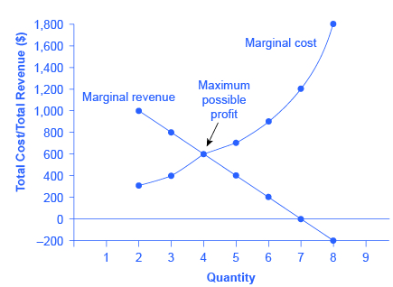
Source: Thomas, and Maurice (2016, p. 62)
From the above illustration (3), the marginal cost is an upward sloping curve which implies that as more quantities are produced, the more marginal cost the firm incurs. Then the marginal revenue curve which slants downward indicates that the marginal revenues reduce as additional units get produced. Ideally, with higher price and lower quantity of output, maximum profits are guaranteed. As long as total revenue (TR) shields the total avoidance costs, the monopolist will produce additional unit. Importantly, the demand curve would inform the price at which the ideal output levels that will yield maximum profits (Thomas, and Maurice, 2016). This price is often higher than the long run average cost and it is where a firm will realize economic profits. If the price falls below the long run average costs, the firm will have to exit the market as shown in illustration (4) below. Ideally, only where the marginal cost equals the marginal revenues, it is where such a firm gets maximum (supernormal) profits (von Blanckenburg and Neubert, 2015).

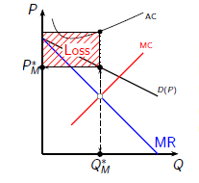  Figure 4: If P<LAC the firm makes losses | 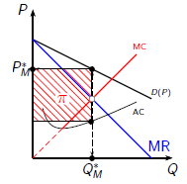  Figure 5: Firm makes profit if P>LAC
Source: von Blanckenburg and Neubert, (2015, p. 3)

A crucial take-away for a monopolistic firm is that the goal should therefore be maximizing marginal revenues as opposed to just maximizing the profits (Mert, 2018). It is because its stability on the market is determined not by the profit maximization conditions but by the at marginal revenue maximization conditions. Mert, (2018) also affirms that if the Lerner index is viewed in term of the profit maximization condition, rather than the revenue maximization, positive Lerner index would reveal significant market power. Nevertheless, the magnitude of the index would not show the market power. For Tesla, as an innovative production firm that seeks equilibrium on the market, emphasis ought to be on conditions that would maximize its marginal revenues.

Further on, in their critique, Reksula et al. (2008) identified that innovation enabled monopolistic firms expand their output levels, cut on costs and reduce their pricing. To lower both the opportunity cost and deadweight costs, innovation need to be prudent embraced so that consumers appeal more to the products produced. As entity closely aligned to innovative practices, the differential value is boosted by these innovations so that it stands out on the market. The company has mad upward improvements in innovation including developing the newer models; Model X, S and Y. More prudently the company has been ambitious enough to cut down on the prices of some of its models. Tesla downsized the price of Model 3 by $2000 to cost about $39,190 currently while models S and X saw significant price cuts of about $5,000 on each model (Beresford, 2020). The price changes are strategic moves to ensure incremental marginal revenues and thus a better grip on the market.

- Theoretical Framework
The relevant theoretical framework to explain the nature of monopolistic markets and managerial decision is the theory of monopolistic competition developed by Professor Edward Chamberlin in 1933 (Rothschild, 2007). In this theory, Chamberlain sought to understand the behavior of firms operating in the monopolistic markets. He perceived that firms in this market offers product that are much differentiated on the degree of suitability. He reasoned that firms in such a monopolistic market will be ‘too small” in relation to their sizes if such differentiation would not occur. This is an ideal example of Telsa which produces cars, just like the other automobile makers, but its products are highly differentiated in that they produce zero emission since they are fully electric. This product differentiation captured the uniqueness of a firm and therefore made it behave like a monopoly, although not in entirety. As for the case of Tesla, its crucial differentiation in commercializing the production of fully electric cars gives a sense of a monopoly to the consumers. Additionally, Chamberlain envisioned that if there are N number of such firms, then the market share of each firm would be 1/Nth of the total demand. He then supposed that if the entry to such a market of blocked (having more entry barriers), each of the firm will seek an opportunity to maximize its profits by lowering their prices (Rothschild, 2007). This would only happen if none of the rival firms make the same move.

Figure 6: Chamberlain's theory on prices and sales in a Monopolist Market.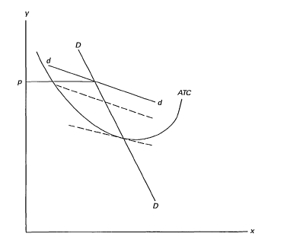
Source: Rothschild (2007, p. 36).

Further on, the theorist asserted that a firm in a monopolistic market will grow its sales revenues by moving downwards on the demand curve which is quite elastic in nature. Nevertheless, as each firm does this, the totality of demand will be inelastic, meaning that price changes will yield only minimal adverse effects on sales. The rush to get a better hold of the market through lowering prices will only end in every firm making only normal profits. The leftward shifting of the demand curve would then stop at a point where the price is equal to the average total costs. As some firms leave the market, the demand curve would shift to the right and eventually the Cournot equilibrium where the marginal costs are equal to the marginal revenues (Rothschild, 2007). Therefore through studying the symmetry and myopic price reductions, Chamberlain established a theory to explain the profit maximization for firms with market power. In the views of Edwards (1933) Chamberlain perceived the market demand as a socially constructed aspect that guided production. On the other hand, production was a financial function limited by technology, high costs and knowledge. It implies that despite the limitations in production, partial monopolies had to accurately read the market and offer at the most appropriate price and output levels.

- Empirical Framework Model for Tesla
The Long Run Equilibrium of Monopolistic Competition Model

Figure 7: The Long run Equilibrium Model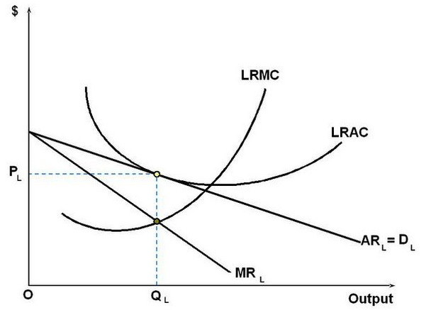
Source: Lumen (2020). Retrieved from https://courses.lumenlearning.com/boundless-economics/chapter/monopolistic-competition/

The most critical aspect in Tesla’s management decisions regarding steering the firm towards a state of equilibrium in a long run. As informed by Chamberlain’s Theory of Monopolistic Competition, in the short run, firms with market power behave like monopolies since demand is inelastic and price changes have a fairly good reception on the market. The challenge however rests with the maintenance of equilibrium on the long run to avoid the risk of accruing more marginal costs in excess of the marginal revenues. In essence, when such a scenario occurs the firm has to exit the market.

- The Analysis of the Equilibrium Empirical Model
  - Decisions to Quantity and Pricing
Unlike in the competitive markets, monopolist firms are price makers as opposed to being price takers. This means that have a pricing power which is embedded in their product differentiation strategy. Tesla for instance, need to ensure that the marginal costs in producing its cars equals to the marginal revenue on the market. Therefore, concerning the determination of the profit maximizing price, the firm map exactly where the profit maximizing output falls on the average revenue curve. As shown in the model above, such a price will be PL. in this regard, the profits that Tesla will make represents the amount of the units produced to the market multiplied by the difference between its price as well as the average cost of production involved.

Profit = Q x (P-AV)

In addition to that seeking the price by which the profits are at maximum requires a detailed review of the marginal revenues and marginal costs. If Tesla’s management ascertains that it produces cars in quantity levels where the marginal revenue is far above the marginal costs, then the company can proceed on expanding its production capacity. Such a time is viable to seek more infrastructure for production such as acquiring more production plants. This is because, for each marginal unit of the automobile rolling out of the assembly line, there is a surety of profit added to the company. It means that the revenues are higher than the costs.

In this respect, Telsa would go on producing up to quantity levels where the marginal revenues equals the marginal costs. In the long run, this move will ensure equilibrium is attained and the firm stays profitable with respect to the demand for zero emission cars on the market. On the converse, if Tesla’s management figures out that the company is registering more marginal costs, higher than the marginal revenues, it means the company is incurring a loss. Put differently, for every extra car rolling out of the assembly line, it is costing more than that the extra revenue expected on it. Therefore, managerial decision is made to cut on output levels or reduce pricing to seek profitability. Usually, in the long run, the price sensitivity is high for firms with market power and thus, it is vital to determine when maximum profits are being realized.

  - Decisions to Variety
In a typical monopolistic market such as in the making of electric automobile production, consumers are usually additively separable (Zhelobodko et al., 2012). It means that their demand in a good depends on the expenditure allocated to the goods in the similar market as well as their prices. In essence, if the price mapping of a good is denoted as p = pi≤N and the associated expenditure with the value E, it means that a consumer’s consumption would be x = xi≤N which seeks to maximize their utility in light of the resource or budget constraints (Zhelobodko et al., 2012).

The utility function would be denoted as;

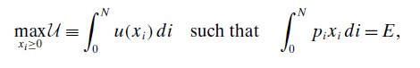
Figure 8: Zhelobodko et al. (2012, p. 2768)
In this function, the concavity u (.) implies that consumers love variety in the goods they aspire to consume. From the perspective of such a typical electric car consumer, for any given quantity Q>0 of the differentiated automobile, u is concave only in the case where nu (Q/n) increases with n. Put in a different way, as opposed to treating their consumption as a one homogenous entity, they uphold small varieties that are spread over a spectrum (Zhelobodko et al., 2012).
As it regards to the management of Telsa, consumers have preference to variety of products if they have the willingness to trade a lower consumption against more differentiation. Fortunately, over the years, Tesla despite having a well differentiated product (a zero emission, fully electric car), it has further invested in more differentiation including developing models S, X and 3. Model Y, the company’s latest model is an all-wheel drive off-road equipped with ultra-responsive, independent electric motors which help to offer traction and stability whilst one drives in rain, mud or snow (Tesla, 2020). This continuous improvements meet the needs of the variety-loving consumers and in turn good market performance imply attainment of equilibrium in the long run. Tesla’s developing automobiles as if they were software, developing sophisticated battery technologies, high variants and even creation of more electric charge points works in favor of their differentiation (Shipley, 2020). Looking toward the future, managerial decisions need to be in favor of more product differentiation to get more appeal in the market which has consumers with diverse preferences.

  - Decisions to Efficiency
If a firm with market power aspires to get a grip on long run equilibrium it is essential to manage efficiency its operations. Efficiency would mean that a firm produces at the lowest average costs possible. Important to note, inefficiency in firms with market power occurs in two ways. Firstly, in levels of optimum output, the firm’s price exceed the marginal costs involved in production. This is revealed in the demand curve which slopes downward. This is the demand curve of the firm which also the same as the market demand curve. The dynamics of market power for monopolistic firms imply that in maximizing their levels of production, the firm experiences net loss attributed to the producer and consumer surplus. Secondly, the firms in the monopolistic markets usually operate in excess capacities. Usually, the output levels that offer maximum profits are less that the output levels attributed to the minimum average costs. Just as the demand curve slopes downwards, there is the risk of excess capacity which accounts for deadweight loss (Lumen, 2020).

In contextualizing this to the case of Tesla, managing efficiency is a crucial component in managerial decision making. A section of the scholarly evidence shows that with technological innovations, partial monopolies such as Telsa can be able to lower production costs thus impacting well on production efficiencies (OpenStax, 2016: Todorova, 2016). As a competitive and tech-savvy enterprise, Tesla can continually invest in cutting edge technologies that will help lower the production costs. Already, Stringham et al. (2015) affirms that Tesla continues to partner with dedicated technology and engineering firms such as the Lotus Elise licensed technology to find very unique and cost effective approaches to develop their cars components. Within the segment of market efficiency, a monopolistically competitive firm such as Tesla need to operate as though it is in a competitive market. Bolder steps to lower production efficiencies would lessen the slope of the demand curve and guarantee better levels of efficiency.

- Conclusion
Firms with market power enjoy a significant degree of demand inelasticity which means that price changes do not have adverse effects on sales revenues. Tesla is an ideal case study of a monopolistically competitive firm since it makes fully electric cars which are highly differentiated from the conventional cars. An analysis of the managerial decision making in such a firm has revealed that the profit maximization decisions focus on achieving a production quantity where the Marginal revenue (MR) is equal to the marginal cost (MC) in the long run. The quantities at which MR curve meets the MC curve can be extrapolated to find the most optimal prices that will yield maximum profits. If MR exceeds MC more output levels can be produced but when MC exceeds MR, then the firm makes losses. This behavior modelling is informed by the theory of monopolistic competition which was developed by Economist Edward Chamberlin in 1930s. Since then, this theory has informed research and practice for decades and accurately explained how management decisions occur in monopolistic firms. This research paper has adequately explained this theory of monopolistic competition and especially critically assessed the equilibrium model of monopolistic competition. While in the short run, firms with market power behave like monopolies with economic profits and well-defined market demand, in the long run decision-making is more challenging. Managers need to map the correct output levels, pricing, and variety of products as well as managing inefficiencies. The case of Tesla has offered a chance to explain these managerial decisions to maintain stability in the market.

- References
Beresford, C. (2020). Tesla Lowers Model S Price Further Despite Price Cuts Last Summer. CarandDriver. Retrieved on 11 November 2020 from https://www.caranddriver.com/news/a32686279/tesla-price-cuts-model-s-model-x-model-3/
Corwin, E. (1933). American Economic Association. The American Economic Review, 23 (4), 683-685
Cowan, S. (2018). Regulating monopoly price discrimination. J Regul Econ 54, 1–13 Doi: 10.1007/s11149-018-9361-2
Debord, M. (2020). Tesla's cars are too expensive, and Elon Musk knows it — here's why that could be a big problem for the electric-vehicle leader. Business Insider Africa. Retrieved on 11 November 2020 from https://africa.businessinsider.com/opinion/teslas-cars-are-too-expensive-and-elon-musk-knows-it-heres-why-that-could-be-a-big/vepl7rr
Lábaj, M., Morvay, K., Silanič, P., Weiss, C., & Yontcheva, B. (2018) Market structure and competition in transition: Results from a spatial Analysis. Applied Economics, 50 (15), 1694-1715, DOI: 10.1080/00036846.2017.1374535
Lumen (2020). Monopolistic Competition. Retrieved on 11 November 2020 from https://courses.lumenlearning.com/boundless-economics/chapter/monopolistic-competition/
Mert, M. (2018). What does a firm maximize? A simple explanation with regard to economic growth. International Journal of Engineering Business Management, 10, 18479790188152
Nowlan, E. (2018). X-Inefficiency in Monopolies. HON499 projects, No. 14.pp. 1-44 Retrieved on 11 November 2020 from http://digitalcommons.lasalle.edu/honors_projects/14
OpenStax, (2016). Principles of Economics. Houston: Rice University. Chapter Retrieved online from https://opentextbc.ca/principlesofeconomics2eopenstax/chapter/how-a-profit-maximizing-monopoly-chooses-output-and-price/
Recvlohe, C. (2018). Tesla Is a Monopoly, We Just Don’t Know It Yet. Medium Corp. Retrieved on 11 November 2020 from https://medium.com/swlh/tesla-is-a-monopoly-we-just-dont-know-it-yet-157131037ef8
Reksulak, M., Shughart, W. F., & Tollison, R. D. (2008). Innovation and the opportunity cost of monopoly. Managerial and Decision Economics, 29(8), 619–627. Doi:10.1002/mde.1425
Rosado-Cubero, A. (2015). Barriers to entry vs. competitive strategy. Business Studies Notebooks, 25, 67-86 Doi:10.5209/rev_CESE.2015.v25.53633
Rothschild, R. (2007). The Theory of Monopolistic Competition: E.H. Chamberlin's Influence on Industrial Organization Theory over Sixty Years. Journal of Economic Studies 14(1):34-54 DOI: 10.1108/eb002641
Shipley, L. (2020). How Tesla Sets Itself Apart. Harvard Business Review. Retrieved on 11 November 2020 from https://hbr.org/2020/02/how-tesla-sets-itself-apart
Stringham, E. P., Miller, J. K., & Clark, J. R. (2015). Overcoming Barriers to Entry in an Established Industry: Tesla Motors. California Management Review, 57(4), 85–103. doi:10.1525/cmr.2015.57.4.85
Tesla (2020). Model Y. Retrieved on 11 November 2020 from https://www.tesla.com/modely
Thomas, C., & Maurice, C. (2016). Chapter 12: Managerial Decision for firms with market power In Managerial Economics, 12th Edition. New York: McGraw Hill.
Thomas, J., and Maine, E. (2019). Market entry strategies for electric vehicle start-ups in the automotive industry – Lessons from Tesla Motors. Journal of Cleaner Production, 235, 653-663 DOI: 10.1016/j.jclepro.2019.06.284
Todorova, T. (2016). Some Efficiency Aspects of Monopolistic Competition: Innovation, Variety and Transaction Costs, ZBW - German Central Library for Economics, Leibniz Information Center for Economics Community Verified, Kiel und Hamburg, pp. 1-11
Von Blanckenburg, K., & Neubert, M. (2015). Monopoly Profit Maximization: Success and Economic Principles. Economics Research International, Vol. 2015, Article ID 875301, 1-10 Doi:10.1155/2015/875301
Zhelobodko, E., Kokovin, S., & Thisse, J. (2012). Monopolistic Competition: Beyond the CES. C.E.P.R. Discussion Papers, CEPR Discussion Papers Econometrica, 80 (6), 2765–2784

